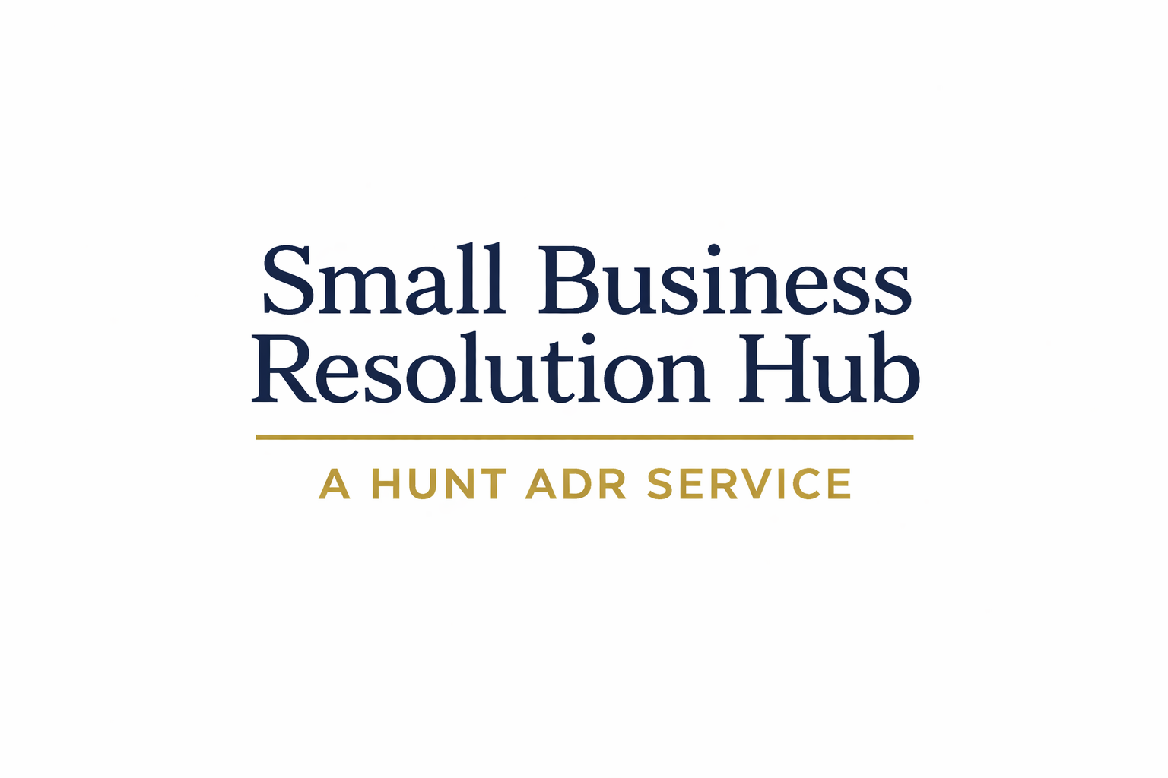

Contract Clauses

1. Recommended Clause: Negotiation → Mediation → Resolution & Arbitration
If a dispute arises out of or in connection with this agreement, the parties shall first seek to resolve it through good faith discussions.
If the dispute is not resolved within 14 days, either party may propose that it be referred to Small Business Resolution Hub – Mediation, administered by Hunt ADR Limited.
If the parties agree to mediation, Hunt ADR Limited shall appoint a Mediator from its list of accredited mediators.
If the dispute is not resolved through mediation within such period as the parties and the Mediator may agree, or if either party withdraws from the mediation, the dispute shall then be referred to the Small Business Resolution Hub (Resolution & Arbitration process) administered by Hunt ADR Limited.
That process shall be conducted in accordance with the Small Business Resolution Hub Rules 2026, as amended from time to time.
Hunt ADR Limited shall appoint a Resolution Neutral from its panel. If the dispute is not resolved, the Resolution Neutral may issue a binding arbitration award. The seat of the arbitration shall be England and Wales. The language of the process shall be English.

2. Standard Resolution & Arbitration Clause

Any dispute arising out of or in connection with this agreement shall be referred to the Small Business Resolution Hub, administered by Hunt ADR Limited.
The dispute shall be conducted in accordance with the Small Business Resolution Hub Rules 2026, as amended from time to time.
Hunt ADR Limited shall appoint a Resolution Neutral from its panel.
The parties agree that:
(a) the process is a structured resolution procedure designed to facilitate settlement; and
(b) if the dispute is not resolved, the Resolution Neutral may issue a binding arbitration award.
The seat of the arbitration shall be England and Wales. The language of the process shall be English.

3. Mediation Clause

The parties will use their best efforts to negotiate in good faith and settle any dispute arising out of or in connection with this agreement, or any breach of it.
If any such dispute cannot be settled amicably through ordinary negotiations, or if either party is unwilling to engage in that process, either party may propose in writing that the dispute be referred to Small Business Resolution Hub – Mediation, administered by Hunt ADR Limited.
If the parties agree to mediation, Hunt ADR Limited shall appoint a Mediator from its list of accredited mediators.
The mediation shall be conducted in accordance with the Small Business Resolution Hub – Mediation Agreement or such procedure as may be agreed by the parties and the Mediator.
The mediation shall be conducted on a confidential and without prejudice basis.
Any settlement reached through mediation shall not be binding unless and until it is recorded in writing and signed by or on behalf of the parties.
If the dispute is not resolved through mediation, or if either party withdraws from the mediation, either party may pursue any other remedy available to it, including referral of the dispute to the Small Business Resolution Hub (Resolution & Arbitration process) administered by Hunt ADR Limited, if the parties so agree or if there is a contractual clause providing for that process.
Any dispute shall not affect the parties’ ongoing obligations under this agreement, unless the nature of the dispute makes continued performance impossible or inappropriate.

4. Escalation Clause (Negotiation → Resolution & Arbitration)

If a dispute arises out of or in connection with this agreement, the parties shall first seek to resolve it through good faith discussions.
If the dispute is not resolved within 14 days, it shall be referred to the Small Business Resolution Hub, administered by Hunt ADR Limited.
The dispute shall be conducted in accordance with the Small Business Resolution Hub Rules 2026, as amended from time to time.
Hunt ADR Limited shall appoint a Resolution Neutral from its panel.
If the dispute is not resolved, the Resolution Neutral may issue a binding arbitration award. The seat of the arbitration shall be England and Wales. The language of the process shall be English.

5. Short-Form Clause

Any dispute arising out of this agreement shall be referred to the Small Business Resolution Hub, administered by Hunt ADR Limited, in accordance with its Rules.
If the dispute is not resolved, it will be determined by a binding arbitration award.

